# Quick Start Information:

The MANTA_MetaData_App allows a user to provide MANTA with the data needed to process raw acoustic data and generate calibrated soundscape outputs. The application is a Matlab ‘AppDesigner’ tool that has a Data Entry Area and a Status Area (Figure 1). The status area has two buttons for Generating MANTA metadata files based on the User inputs and loading existing files for editing. There are also four go/no go (red/green) status lights to indicate if system has found all information needed to generate a MANTA file. The Data Entry Area allows the User to enter basic information on the deployment as well as detailed information on the recorder and sensors. There is also an output tab for Calibration results.

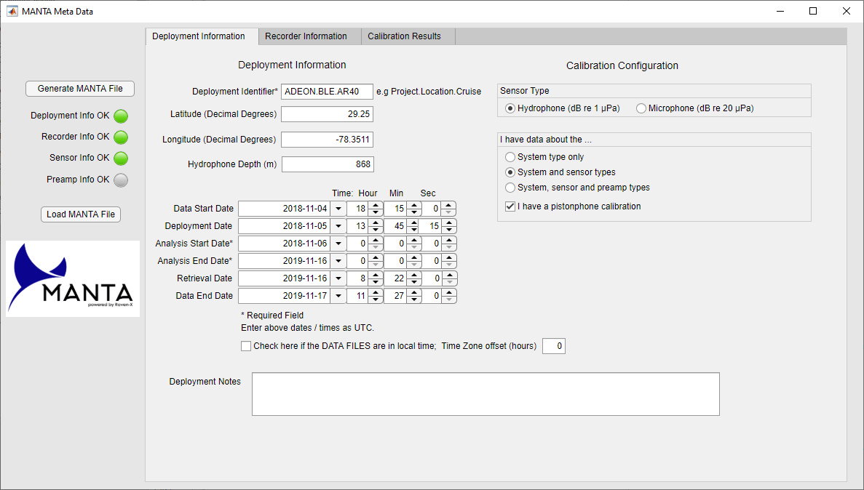 Figure . MANTA Meta Data App front page. The Status Area on the left has two buttons and four go/no go status lights. The Data Entry Area on the right has three tabs for Deployment Information, Recorder Information and Calibration Results.

The Deployment Information tab is used to enter basic information about the deployment: An identifier (such as Project.location.cruise e.g. ADEON.BLE.AR42), recorder latitude, longitude, depth and key dates. As a minimum the Deployment Identifier, Analysis Start Date and Analysis End Date must be completed for the ‘Deployment Info OK’ light to turn green. The primary purpose of the MANTA software is to quantify *ambient* sound levels in long-term datasets. Therefore, the Analysis Start Date should be set for a time after the deployment vessel has left the project area; the MANTA processing software will start computations at this time. Selecting midnight, UTC, the day after deployment is recommended. Similarly, we recommend setting the Analysis End Date to be midnight, UTC, the day of retrieval.

The right-hand side of this tab allows the User to tell the App about the type of sensor, system and calibration information they have available. The operation of the Recorder Information tab depends on these settings. The available sensor types are Hydrophones, in which case sensitivities are assumed to be reference to 1 µPa, and Microphone in which case the sensitivities are assumed to be reference to 20 µPa. The available system configurations are:

1. System Only: This option is used for systems where the sensor and recorder are an integrated unit and a nominal calibration curve is provided.
2. System and Sensor: for this option, the User has the type of recorder and sensor, with nominal calibration curves for both.
3. System, hydrophone, and pre-amp: in this case the hydrophone and preamp are separate units with per-unit calibrations. The Preamp Info status light is only active for this configuration.

The user also has an option to provide a single frequency calibration value from a pistonphone.

The Recorder Information tab is shown in Figure 2. The recorder section of the tab is where the User tells MANTA about the acoustic recorder. The principle widget is the ‘Recorder Type’ drop-down menu which allows the user to select from a list of common acoustic recorders (see Section below). Once this recorder is selected the remaining fields auto complete, except for the recorder serial number. It is strongly recommended that the User enters this information, i.e. AMAR45 or icListen1405. If the type of recorder is not available from the drop-down menu the User may enter the fields directly. Further information about each field is provided in the Recorder Types Section below. The sample rate, ADC bits and maximum input voltage fields must be completed for the ‘Recorder Info OK’ status light to turn green.

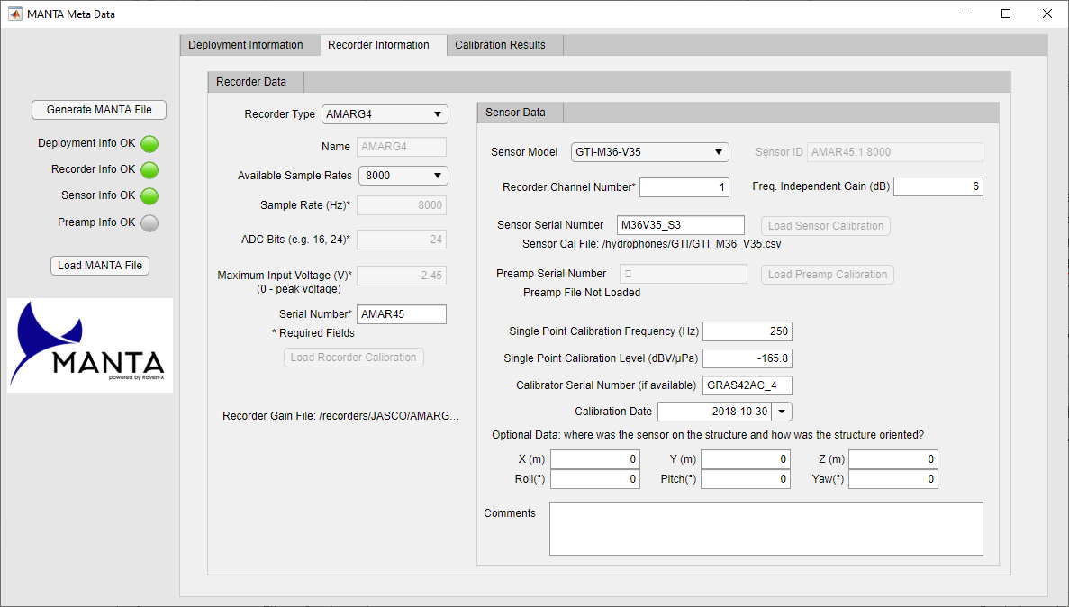

Figure . Recorder Information tab for entering information on the recorder unit and the sensor..

The right-hand side of the Recorder Information tab is where the User tells MANTA about the sensor. Like the Recorder Type drop-down menu, the principal widget for the sensor is the ‘Sensor Model’ drop-down which allows the User to select from a list of common sensors and their associated nominal calibrations. The ‘Sensor ID’ field auto-completes with the pattern of ‘Recorder Serial Number.Recorder Channel.Sampling Rate’. The Single Point Calibration Frequency and Single Point Calibration Level must be completed when the ‘I have a pistonphone calibration’ CheckBox is enabled on the Deployment Information tab. The remaining fields are optional. The role of each of the gain and sensitivity values in obtaining the final analog sensitivity is discussed in Section ‘Computing the Analog Sensitivity’ below.

The final tab is the Calibration Results tab that provides a graphics representation of all the User input for verification before writing the MANTA Calibration Information file (Figure 3). The example shows the possible sensitivities and gains that are summed to obtain the final analog sensitivity (see below)

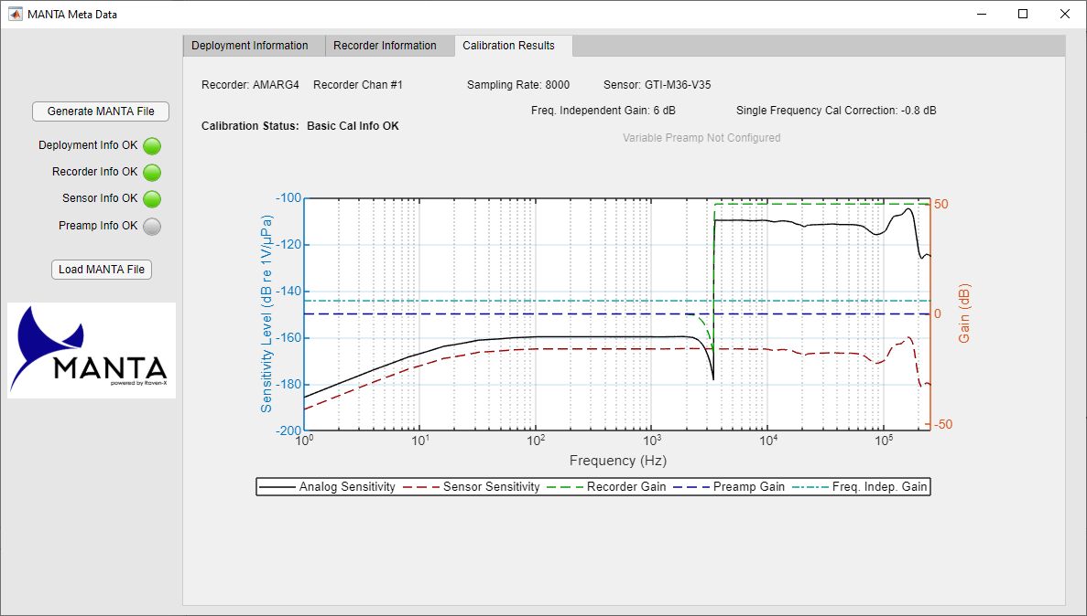

Figure . Calibration Results Tab.

# Computing the Analog Sensitivity

The MANTA MetaData App output is an MS Excel file with two worksheets – one for the deployment and basic calibration information, and one for the frequency dependent calibration curves. The analog sensitivity is the sum of all of these values and is the curve used by MANTA. Working in decibels (dB), the analog sensitivity (*LA*) is:

$$L_{A}=L_{S}+G_{R}+G_{PA}+G_{FI}+G_{SFC}$$

These values are:

1. *LS* is the sensor sensitivity level: the default for the sensor model, or from a sensitivity file loaded using the ‘Load Sensor Calibration’ button.
2. *GR* is the frequency dependent recorder gain, which is either the default for the recorder sampling rate, or loaded using the ‘Load Recorder Calibration’ button. For integrated recorder/sensor combinations *GR* is zero and the combined sensitivity is stored in *LS*.
3. *GPA* is the frequency dependent preamplifier gain which is loaded using the ‘Load Preamp Calibration’ button.
4. *GFI* is the gain entered at the ‘Freq. Independent Gain (dB)’ text entry field. This gain is commonly applied by a variable gain preamplifier at the front end of the analog to digital conversion system.
5. *GSFC* is the gain correction for the single frequency calibration. *GSFC* is the difference between the sensor sensitivity level (*LS*) and the level measured during the single frequency calibration.

The MANTA application will use the maximum input voltage, ADC bit and analog sensitivity to convert the recorded digital data to the pressure (*P*) in Pascals.

$$P=\frac{2*V}{2^{ADCBits}}{10}^{{\left(L_{A}-120-L_{Ref}\right)}/{20}}$$

Where *V* is the maximum input voltage, *LRef* is the reference in dB re 1 µPa (i.e. 0 for hydrophones and 26 for microphones). The value of 120 converts from µPa to Pa.

# Configuring Recorder Types

Recorder types that MANTA knows about are contained in the file ‘RecorderTypes.xlsx’, located in the same directory as the MANTA_MetaData_App file. An example of this file is shown in Table 1. The columns of this file are:

1. Recorder Name: this is the brand name that the recorder is known by. Multiple entries for the same type of unit are possible as long as the sampling rate, maximum input voltage, ADC Bits or calibration files are different. Having one line per recording frequency supported by the device is recommended. This is a free text field. In the MANTA MetaData App, there is not field available for different input filter configurations, therefore the recorder name should specify this option and each filter option should have its own line per sampling rate (for example the SoundTrap lines).
2. Sampling Rate: one of the available sampling rates for the device.
3. Maximum Input Voltage: the voltage at which the device saturates. All devices are assumed to have a symmetric voltage swing, i.e. if Maximum Input Voltage is set to 5 V, then we assume the hydrophone and any preamplifiers will provide -5 to 5 V to the ADC.
4. ADC Bits: this field specifies the number of digital levels that an analog-to-digital (ADC) converter uses to represent the analog data. Typical values are 16 and 24, i.e. 216 or 224 levels from the converter. It is essential for interpreting the digital data.
5. Separate Sensor Cals: this field is either ‘Y’ or ‘N’. ‘Y’ indicates that the device does not have a permanently attached hydrophone and a separate hydrophone will be specified. ‘N’ is for devices like the icListen where the hydrophone is built in.
6. Nominal Calibration File: this the relative path to a ‘.csv’ file that contains the nominal calibration of the recorders. These files have two columns – frequency and sensitivity. For devices with built-in hydrophones, it is expected that the sensitivities will be between -80 and -240 dBV/µPa for hydrophones and ?? for microphones, while for devices without sensors the values are expected to be between -80 and 80 dB. The path to the files is relative to the directory that contains the MANTA MetaData App. The folder structure that is delivered with the App has each manufacturer’s nominal calibration files in separate folders.

It is expected that recorder manufacturers will provide the nominal calibration files and the necessary information to populate the RecorderTypes.xlsx file. The latest versions of these files may be obtained from the MANTA Wiki.

If a User has a custom acoustic recorder, they may directly enter each of the settings about their recorder directly into the Recorders Panel of the MANTA MetaData App. There is also an option to load the calibration response of the recorder as a two-column calibration file. This file maybe stored anywhere on the User’s computer.

Table . Example of the MANTA RecorderTypes.xlsx file.

|  |  |  |  |  |  |
| --- | --- | --- | --- | --- | --- |
| Recorder Name | Sampling Rate | Maximum Input Voltage | ADC Bits | Separate Sensor Cals | Nominal Calibration File |
| AMARG3 | 125000 | 5 | 16 | Y | /recorders/JASCO/ AMARG3_recorderSensitivityLevel.csv |
| AMARG3 | 8000 | 2 | 24 | Y | /recorders/JASCO/ AMARG3_recorderSensitivityLevel.csv |
| AMARG4 | 8000 | 2.45 | 24 | Y | /recorders/JASCO/ AMARG4_8kHz_recorderSensitivityLevel.csv |
| AMARG4 | 32000 | 2.45 | 24 | Y | /recorders/JASCO/ AMARG4_32kHz_recorderSensitivityLevel.csv |
| icListen | 512000 | 5 | 24 | N | /recorders/OceanSonics/icListenHF.csv |
| SoundTrap300_ HPFOff | 24000 | 5 | 16 | N | /recorders/OceanInstruments/ST300_HPFOff.csv |
| SoundTrap300_ HPFOff | 96000 | 5 | 16 | N | /recorders/OceanInstruments/ST300_HPFOff.csv |
| SoundTrap300_ HPFOn | 96000 | 5 | 16 | N | /recorders/OceanInstruments/ST300_HPFOn.csv |

# Configuring Hydrophone Types

Hydrophones and Microphones that MANTA knows about are listed in the file ‘SensorTypes.xlsx’ located in the same directory as the MANTA_MetaData_App file. An example of this file is shown in Table 1. The columns of this file are:

1. Recorder Name: this is the brand name that the recorder is known by. Multiple entries for the same type of unit are possible as long as the sampling rate, maximum input voltage, ADC Bits or calibration files are different. Having one line per recording frequency supported by the device is recommended. This is a free text field. In the MANTA MetaData App, there is not field available for different input filter configurations, therefore the recorder name should specify this option and each filter option should have its own line per sampling rate (for example the SoundTrap lines).
2. Nominal Calibration File: this the relative path to a ‘.csv’ file that contains the nominal calibration of the recorders. These files have two columns – frequency and sensitivity. For hydrophones, it is expected that the sensitivities will be between -80 and -240 dBV/µPa for hydrophones and ?? for microphones. The path to the files is relative to the directory that contains the MANTA MetaData App. The folder structure that is delivered with the App has each manufacturer’s nominal calibration files in separate folders.

It is expected that recorder manufacturers will provide the nominal calibration files and the necessary information to populate the SensorTypes.xlsx file. The latest versions of these files may be obtained from the MANTA Wiki.

If a User has a custom sensor, or a calibration of the sensor performed at an appropriate facility, there is an option to load the sensitivity as a two-column (frequency, sensitivity) calibration file. This file maybe stored anywhere on the User’s computer.

Table . Example of the MANTA SensorTypes.xlsx file

|  |  |
| --- | --- |
| sensorType | NominalCalibrationFile |
| GTI-M36-V0 | /hydrophones/GTI/GTI_M36_V0.csv |
| GTI-M36-V35 | /hydrophones/GTI/GTI_M36_V35.csv |
| HTI-99-HF | /hydrophones/HTI/HTI_99_HF.csv |

# Configuring Preamplifiers

The MANTA MetaData App supports two types of preamplifiers:

1. The User may specify a fixed gain on the Sensor Data tab.
2. The User may choose to import a calibration file for a specific preamplifier as a two column (frequency, sensitivity) calibration file. This file maybe stored anywhere on the User’s computer.