New Geometry Node Workflow (Geograft Merging)

An update has been made to the merge by geonodes feature in order to make it even less destructive. The change will now create a separate node tree (geometry node modifier) for each geograft.

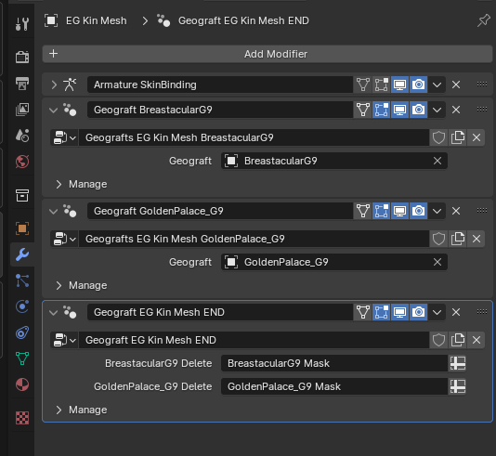
The “END” modifier will delete the appropriate vertices from any of the above geograft/geonode modifiers. This is done after all of the geograft modifiers in order to avoid difficulties encountered if deleting geometry and then merging another graft. This END/delete modifier will be automatically purged & recreated if another graft is merged, so it is not necessary to merge the geografts simultaneously if it is not desired. It is important, however, to keep this END modifier AFTER all of the geograft/merge modifiers. So long as it is not manually moved out of order, this will be the case.

Also, do not place them above the Armature modifier.

This END modifier will be “per mesh.” So, if you have a geograft on a geograft (example of roasty & futa given in original blog post on geografts), the same logic will apply, and you will see the same setup on the geograft object in question.

Because this is non-destructive, and the END modifier is regenerated upon any merge, the order of the merge is not important as it is with the traditional merge method—including grafts on grafts. Any merge should be able to be done at any time.

There are, however, some caveats to bear in mind. The most important one is, it is probably not advisable to use geonodes if you plan to eventually apply the modifiers. This is because the vertex groups will not be preserved, and this will ruin any thought of rigging.

A workflow in which this may be more useful would be if your geograft has its own rig, and you intend to manipulate the graft and/or its rig independent of the figure mesh/rig.

This brings us to a general concept: Geometry nodes “calculate” the changes. So, when using them, it is best not to think of the figure as a single object. It is calculating the changes/grafts based on the graft object(s). If, for example, you wished to change the shape of a graft, you would want to unhide it, then do as you wish to the graft object itself, then hide it again, and the changes would then be reflected on the figure w/ the geonode modifier(s). Similarly, you could pose your geograft if it has its own rig, or add shapekeys to the graft—but all on the graft object itself.

Essentially, if you want a single object, or you want to merge rigs, etc… of a graft & your figure, geometry nodes would likely not be your preferred solution.

