TM1Web Websheet only able to be accessed by admin

I have created a websheet using TM1Web Websheet under Dashboard as picture 1
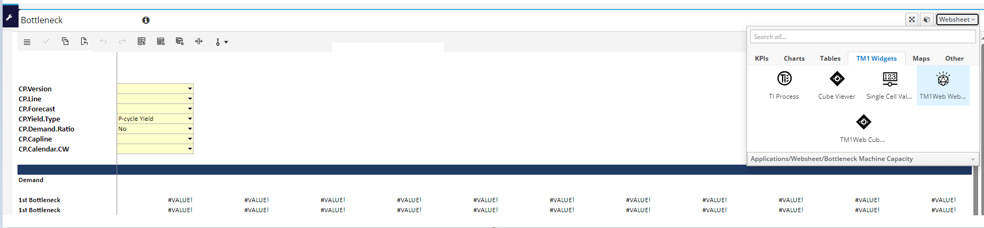
Picture 1
However, when I published this page for my users to test, the page keep on loading as Picture 2
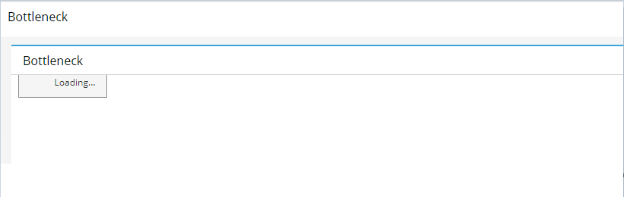
Picture 2
After doing some testing, found that only user has the admin right can see and run the websheet

