- Open the solution MyCLanguageService.sln. Find the project “VSIXProject1”,set this project as the start project.
- Check MyCLanguageService project having all the reference .As displayed below. In case Irony will gave error, then we can find Irony.dll, it’s in Resources folder and give again reference to the project.

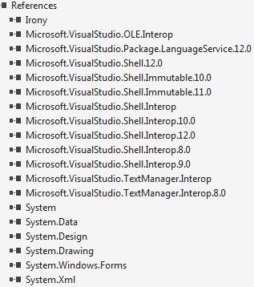
- Make sure the VSIXProject1 having a reference of the MyCLanguageService.
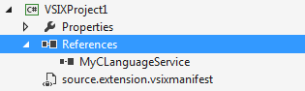
- After all these check we can run the project.It will open new instance of visual studio 2013.Then file>open,any test file having the extenstion .myc.
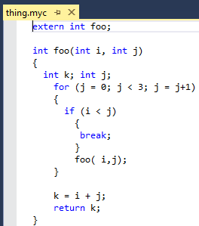
- Type any keyword. It will show you the intellisense window
