DTI pipeline for SC DTI Processing and Analysis
Note that the ACID toolbox is continuously being updated and its GUI being changed, which can make the information presented here outdated. However, you can always get up-to-date information on the tools in the GUI help fields. The theory behind these tools is not detailed here. For more information, see the upcoming paper David et al., 2019.
- Preparations
This section focuses on bringing your dMRI data into the right format before pre-processing. More specifically, you will have to convert your dMRI dataset from the DICOM format (the format Siemens uses for storing medical images) to Nifti format (the format the neuroscience community uses because of its simplicity). Also, as a dMRI dataset consists of a series of images, it is highly recommended to convert your data into 4D format to keep a better overview of the content of your folder.
A big emphasis should be given to a nice folder and file structure. A clearly and consistently structured data will save you a lot of time later on.
  - Convert DICOM to NIFTI
Tools:
dcm2niigui converter of MRICron. Located in mricron/dcm2niigui.exe
choose FSL 4D Nifti as output format
SPM DICOM Converter

Out of these two tools, dcm2nii has the advantage that it returns the b values (*.bval) and the normalized diffusion direction (*.bvec) of the dMRI experiment, which is stored in the DICOM header.

  - Convert the dMRI data from 3D to 4D
Note that this step is not necessary if you converted the data to NIFTI using dcm2niigui and selected FSL 4D Nifti as output format.
Tools:
spm_file_merge command in Matlab (prerequisite: SPM toolbox)
fslmerge in bash

  - Rename the file with a meaningful name.
e.g.: DWI4d_P01.nii; indicating the type of data (DWI), the structure (4d), and the identifier of the subject (P01)
Make sure to include the subject identifier in the filename.
IMPORTANT: At this point, it is highly recommended to create a copy of the data and save it in a secure place. Subsequent pre-processing might alter your raw (unprocessed) images as well, so make sure you have a safe copy of the data somewhere else what you can retrieve in case you need it.

- Pre-processing
The overwhelming majority of in-vivo human dMRI data is acquired using echo-planar imaging (EPI) sequences due to its speed and low sensitivity to motion artifacts. However, an EPI sequence is very sensitive to eddy-current induced geometric distortions. Although motion artifacts are unlikely to appear in a single image (as it is acquired within a few seconds), motion within the scanning duration will introduce spatial inconsistencies across the dMRI volumes. Susceptibility artifacts are also a problem in spinal cord imaging. These artifacts, if uncorrected, will propagate into the tensor fitting and will seriously bias the elements of the diffusion tensor and consequently the DTI scalar values.
Therefore, the data need to undergo pre-processing before tensor fitting. Several software packages have been developed to perform artifact correction on dMRI data; however, most of these packages are meant for brain, and not for SC DTI data. As the nature and extent of artifacts appearing in the SC are quite different from that appearing in the brain, tailored tools are required for spinal cord DTI artifact correction.
Here, I recommend using the SPM-based ACID toolbox, as most of its tools were optimized for SC DTI as well and it offers some handy tools for visual check and diagnosis of SC data. In the following, the steps of artifact correction are described as appearing in the ACID toolbox, but sometimes alternatives are given as well.
  - Data quality check
Extremely important!!! Before doing any processing with the data, do not forget to visually inspect all slices and all volumes of your dMRI dataset. It will give you an idea of the general data quality and level of artifacts in your data. Look for the following things:
- Motion and eddy current artifacts: stream through the dMRI volumes (as in a video) and look for geometric distortions and spatial inconsistencies. In the absence of these artifacts, the images should not move.
- Susceptibility artifacts: look for constant geometric distortions which do not change across volumes but appear the same.
- Signal dropout: look for artificially dark regions across the volumes. These artifacts can have various sources (susceptibility artifact, etc.). They are always present at and around implants in SCI patients and sometimes present around the stenosis in myelopathy patients.
- Ghosting: look for image ghosts (N/2 ghosts), caused by imperfect suppression of the signal outside the FOV. They are generally no problem only if they overlap with the SC itself.
- Other artifacts: look for any suspicious signals. Hyperintense stripes, hypointense slices, etc. are not unusual in SC DTI.
Tool for checking data quality:
‘Visual inspection’ tool of the ACID toolbox
SPM -> Tools -> ACID Toolbox -> Miscellaneous -> Visual inspection
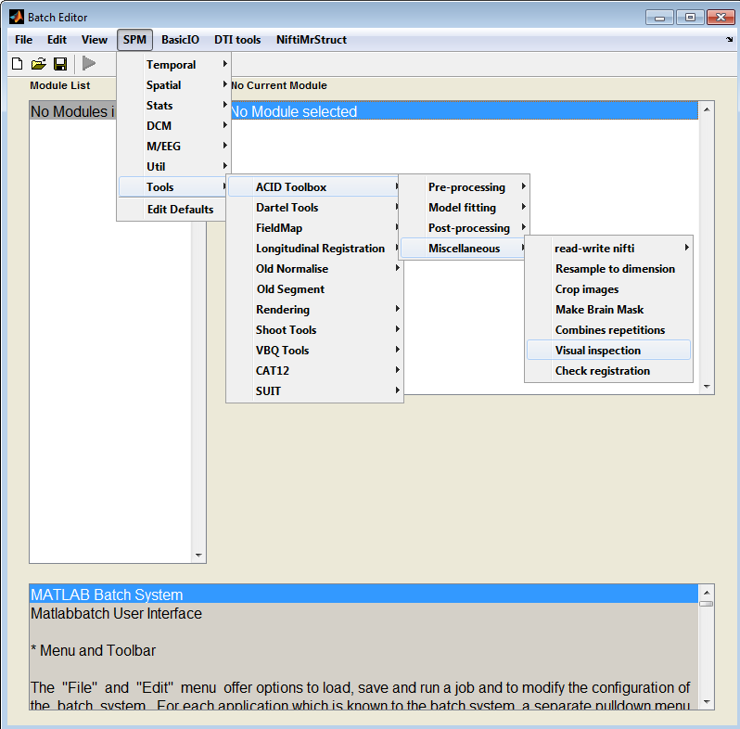
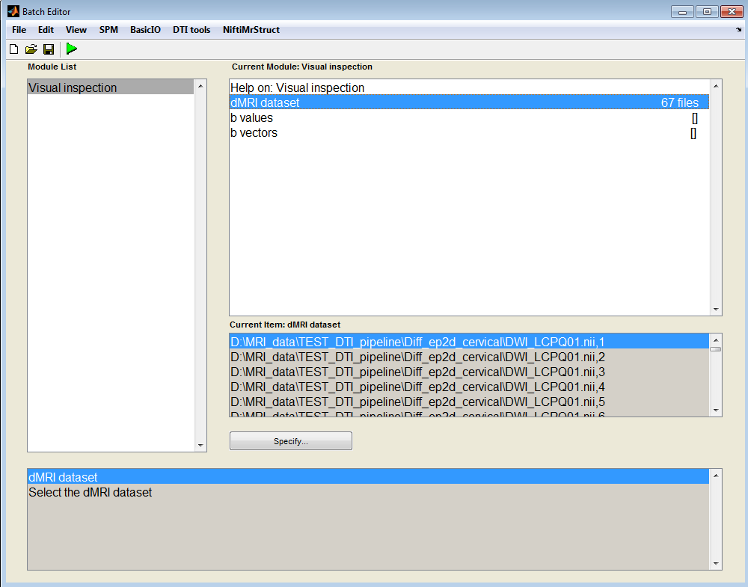

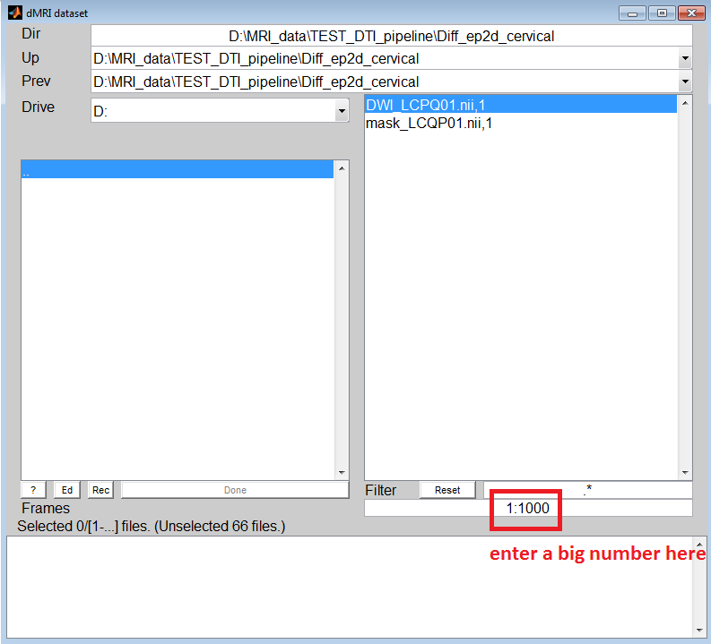

dMRI dataset: select the 4D dMRI dataset in the appearing window. Make sure to select all volumes of the dataset (not just the first one) by entering a large number in the field below the file selector (see red marking in figure below).
b values:
b vectors:

Optionally, you can also enter the b values and b vectors (normalized diffusion gradient directions), which will display these parameters above the volumes during visual inspection. There are several options regarding how to enter b values and b vectors. If these values are stored in .bval and .bvec files, open the files with an advanced text editor (recommended: Notepad++) and copy their content into the corresponding fields in the GUI. If they are stored as .mat files, just load them in your workspace and type the name of the variables in the GUI. The variables present in your workspace are visible to the ACID GUI.

After selecting the dMRI volumes you want to inspect (and optionally the bvals and bvecs), the window shown below will appear. In the middle, you see a slice of your dataset, while on the left you see two sliders which let you select the volume and slice of the dataset you want to inspect. I recommend to stream quickly through all volumes by pressing the volume slider, similar to playing a video. Repeat the procedure for all slices. This will reveal all sorts of spatial inconsistencies across the volumes. After you have identified a slice with significant artifacts, you can label this slice by pressing the ‘Label’ button in the left bottom of the window, which will save the volume and slice number in a file called ‘labeled_slices.mat’. Importantly, this mat file can be loaded into ecmoco (see next chapter). Since geometric artifacts can be corrected later, I recommend labeling only slices affected by signal dropouts, as this kind of artifact is irreversible.

You can also use other tools to visually inspect your images.

FSLeyes is a nice voxel-based image visualization tool where you can load in a whole 4D dataset and scroll through them in a video mode. The tool is useful as images can be opened very quickly for a rapid check and multiple images can be loaded in as well. Furthermore, ROIs can be overlaid on the images.

SPM CheckReg can also open a 4D file but in a bit cumbersome way. First, you have to open the first image, then right click, then Browse…, and select all images. Now you can stream through the images. The advantage of this tool is that you can create intensity time series of a given voxel across the volumes by clicking right_click -> Browse -> Display profile.

  - Cropping images
Most SC DTI sequences use reduced-FOV or ZOOM sequences which feature a small FOV in the phase-encoding direction (typically anterior/posterior) and a large FOV along the frequency-encoded direction (typically left/right) (see figure above). This means that the FOV covers a whole lot of structures outside the SC. These regions can move independently from the SC and thus negatively affect the performance of ecmoco (see next section). For this reason, it is common practice to crop the SC DTI images in the axial plane to include only a smaller segment covering the spinal cord.
In Balgrist data, we have the routine of cropping the initial rectangular-shaped FOV to a square-shaped FOV in the axial plane. For example, an original FOV of 352x80x10 will be cropped to the size of 80x80x10.

For cropping, I use the ACID tool specifically designed for this purpose:
SPM -> Tools -> ACID Toolbox -> Miscellaneous -> Crop images
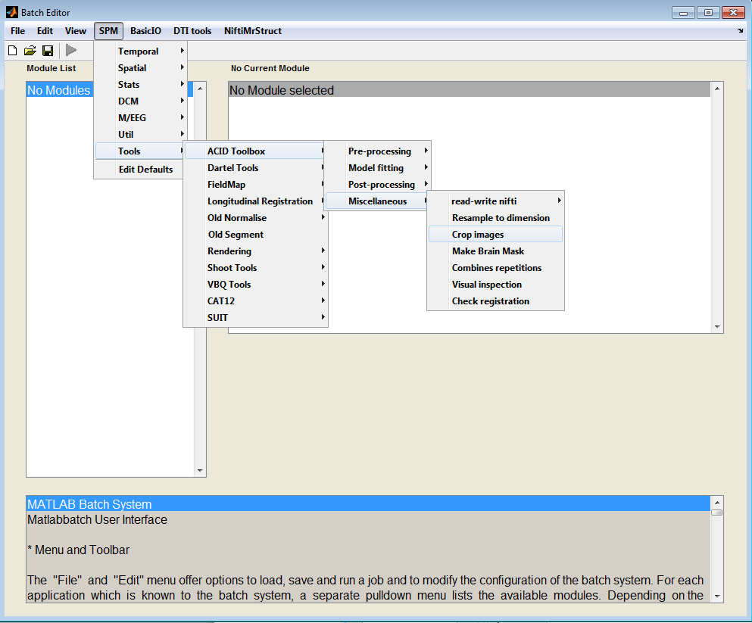

The following input parameters have to be specified (see figure below):
Dataset to be cropped: load in your dMRI dataset
New image matrix: the desired FOV of the cropped image
Middle slice: the middle slice, around which the image will be cropped along the z-axis
Midpoint in the axial plane: the indices of the midpoint in the axial plane, along which the image will be cropped in the plane. If left unspecified (click OK without having entered a value), a window will pop up showing the specified middle slice of the first volume. In this window, you have to manually select the midpoint by moving the cursor to the desired point and pressing the left mouse button.
Prefix for output: prefix for the output cropped image
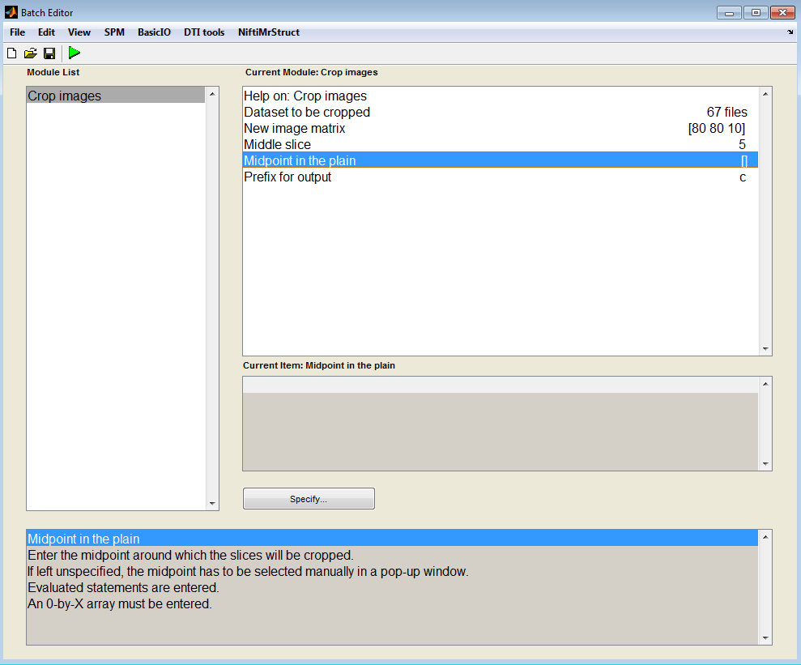

If the
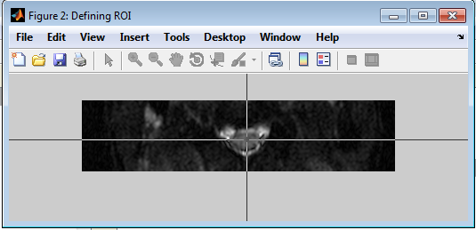

  - Eddy current and motion correction (ECMOCO)
As both eddy current and motion artifacts manifest themselves as spatial displacements/distortions, they can be corrected at the same time in the framework of a linear registration.

The ACID ecmoco tool is found under:
SPM -> Tools -> ACID Toolbox -> Pre-Processing -> ECMOCO -> Estimate and write ECMOCO
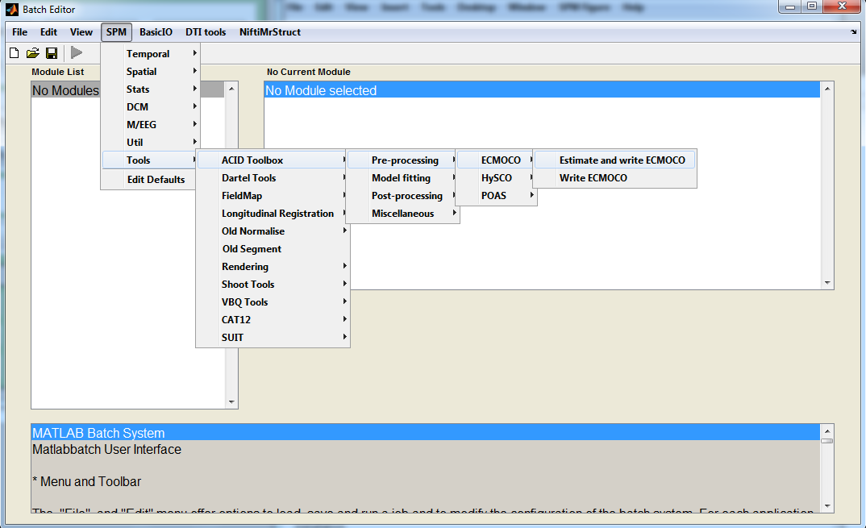

The input parameters required by ecmoco GUI:
Source images: select the cropped dMRI images (cDWI_*.nii)
Registration type: select between volume-wise and slice-wise registration. Use slice-wise registration for SC DTI. Note, however, that slice-wise registration is also preceded by a volume-wise registration.
Degrees of freedom for volume-wise registration: define the degrees of freedom (DOF) of the volume-wise linear registration. See help field for more information.
Recommended for SC DTI: 1 1 0 0 0 0 0 1 0 0 0 0
Degrees of freedom for slice-wise registration: define the DOF of the slice-wise linear registration. See help field for more information. Recommended for SC DTI: 1 1 0 0 1 0
b values: enter the corresponding b values of the selected dMRI volumes (see ‘Data quality check’ section for how to do it).
Initialization mode: If this option is on, the iteration of the transformation (trafo) parameters will be initialized by the interpolated values of the trafo parameters of the b0 volumes. Recommended to use it for SC DTI.
Excluded volumes: The indices of volumes entered here will not be fed into the registration algorithm. Instead, the transformation parameters of the neighboring volumes will be applied to them. Tip: Enter here the volume indices that you labeled during visual inspection of the data and are stored in the ‘labeled_slices.mat’ file.
Bias field image: not recommended for SC DTI. Leave it unspecified by clicking ‘Done’.
Defaults: it contains a number of options related to the display and saving of the transformation parameters and corrected images. Recommended: keep the default options.
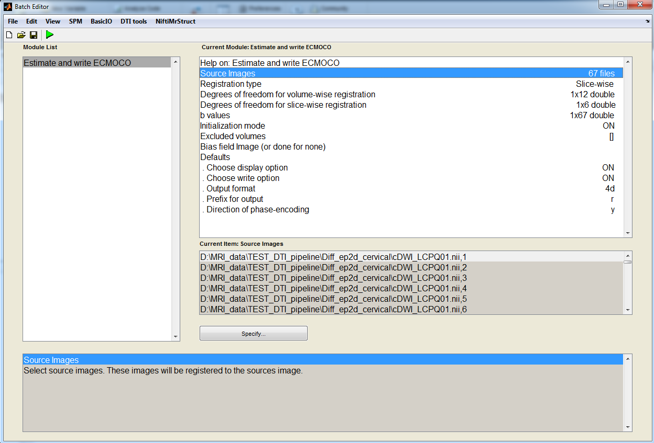
After running the batch, the estimated registration parameters will be stored in a mat file (ecmoco_pars_*.mat). These registration parameters are also plotted in figures and saved as fig files (MO_pars_*.fig and EC_pars_*.fig) if the display option is set ON. I suggest you look at these plots to get an idea of the level of motion artifacts in your data. You should get suspicious if you notice spikes in slices, they should be a sign of misregistration. But, only the next step (check registration quality) will bring quality whether
The ECMOCO corrected dataset will be saved with prefix ‘r’ (rcDWI_*.nii). Use this file for further analysis.
  - Check registration quality
In general, it is highly recommended to check the data quality after each processing step. In this spirit, inspect the data once again after ECMOCO. For this purpose, ACID offers a handy tool that lets you compare the data before and after ECMOCO and thus allows you to readily assess the performance of ECMOCO and to identify potentially mis-registered slices.
SPM -> Tools -> ACID Toolbox -> Miscellaneous -> Check registration

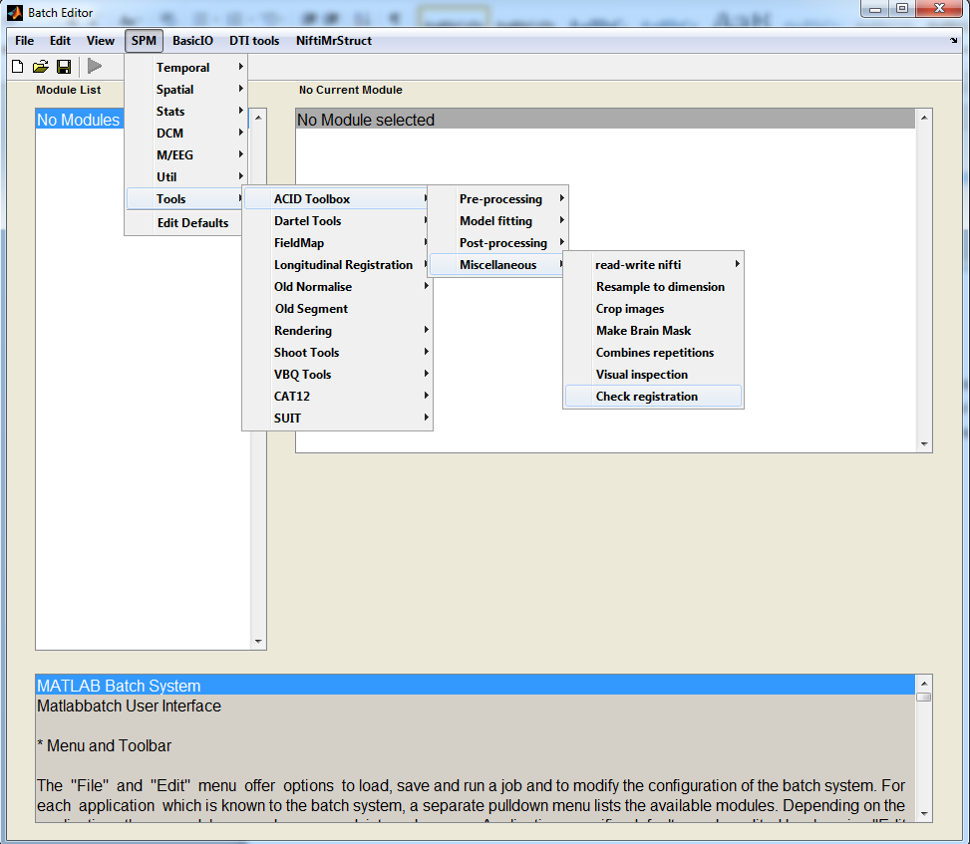
The following input parameters have to be given:
Reference image: enter a non-distorted file here, e.g. the first volume of the ECMOCO corrected dataset (which is always a b0 volume in Balgrist data). Note that here you have to specify a single volume, not the whole dMRI dataset.
- dataset: enter the raw dMRI dataset here (cDWI_*.nii).
- dataset: enter the ECMOCO corrected dMRI dataset here (rcDWI_*.nii).
- dataset: leave it unspecified by clicking ‘Done’ without having selected any images. Alternatively, you can enter here another EMOCO corrected dMRI dataset if you have used two ECMOCO approaches (e.g. slice-wise and volume-wise) and you want to correct them.
Display all slices?: Recommended option is ‘All slices’. More information in the GUI help field.
If all slices, in which order?: Keep default option, ‘first volumes’. More information in the GUI help field.
Slice position: Leave it unspecified. A value has to be entered only if a single slice is intended to be displayed two fields above.
Save movie?: Recommended option: Yes. This will save a movie of the display window while streaming through the images. Note: the frame rate of the saved video is very high. I recommend using a video player software that lets you slow down the video (e.g. VLC Media Player).
Time interval: the time duration between two frames. Recommended: 0.2.
Interpolation kernel: Leave it default.
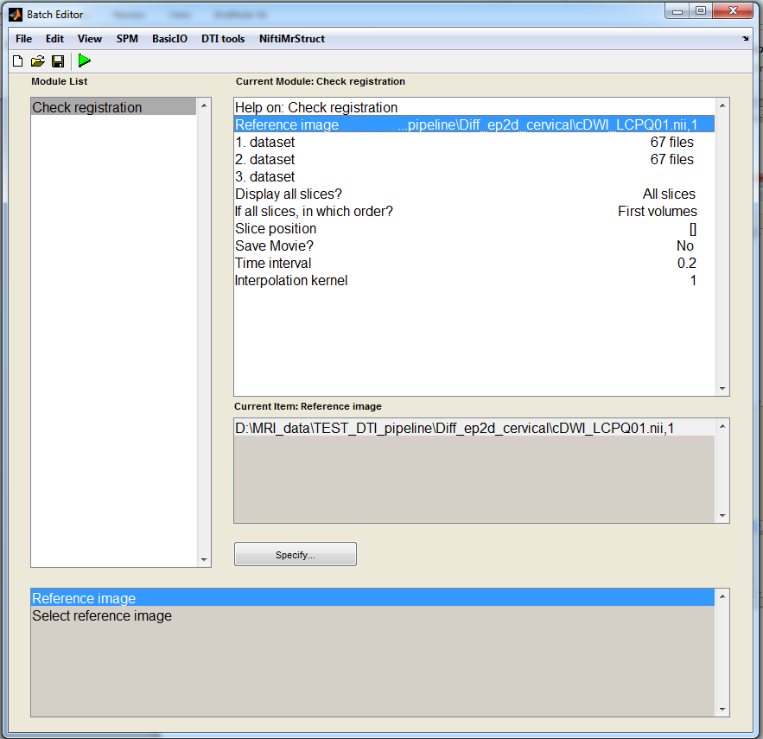
After running the batch (green triangle in the upper left corner), a Matlab window will appear with the reference image, 1. dataset, 2. dataset, and 3. dataset from left to right. Then, the tool will stream through the volumes of the dMRI dataset in a video mode. The procedure is repeated for each slice. Compare the raw and ECMOCO corrected dataset in terms of motion across volumes. You should see less motion in the ECMOCO corrected dataset than in the raw images. However, in case of a normal dataset with minimal motion artifacts the difference is quite small.
What to do if you notice mis-registration in the ECMOCO corrected dataset? For example you notice slices which are completely off due to an error in the registration process. In this case, I recommend you to try volume-wise registration. Slice-wise registration can be instable in case of low-SNR data.
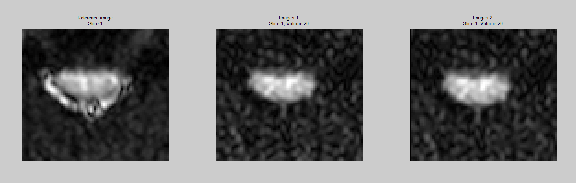

- DTI fitting
  - Estimating the background noise
If you use robust fitting to fit the diffusion tensor on your data (recommended approach), it is important to estimate the background noise (hardware-related) noise in your data. The robust fitting algorithm assigns weights to each data point in the fitting process, and the weights depend on the relation of the signal in the given voxel to the background noise (see Zwiers, 2010 or upcoming paper).
To get an estimate of the background noise in your dMRI dataset, go to
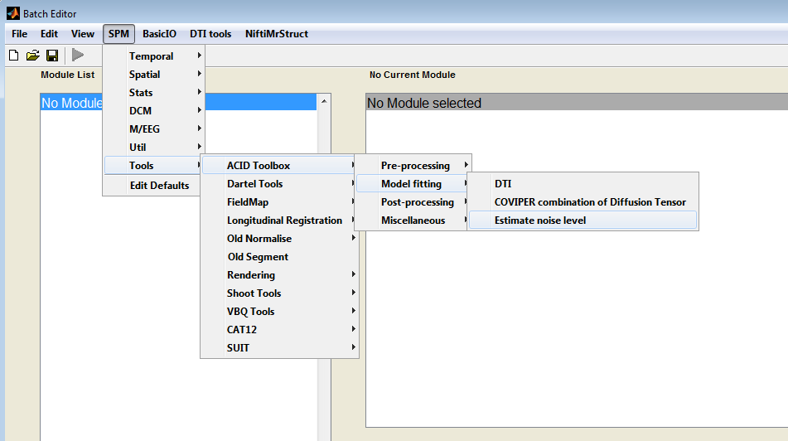

The following input parameters have to be specified:
DW image to estimate noise: specify a single diffusion-weighted (DW) image from your dMRI dataset, in which the background noise will be estimated. Make sure to select only a single file out of your 4D dataset. Look up the indices of DW images in your bval file and select one of them. Importantly, you want to select an image from your uncropped dataset here, as cropping eliminates regions outside the spinal cord.
Region of interest: Here you have to select a binary mask covering a background region (outside the spinal cord) of the DW image selected above. To create such a mask, I recommend using the mask drawing capabilities of FSLeyes or MRICron. Load in the DW image selected above an into FSLeyes or MRICron and select a noise region outside the spinal cord (see below for an example).
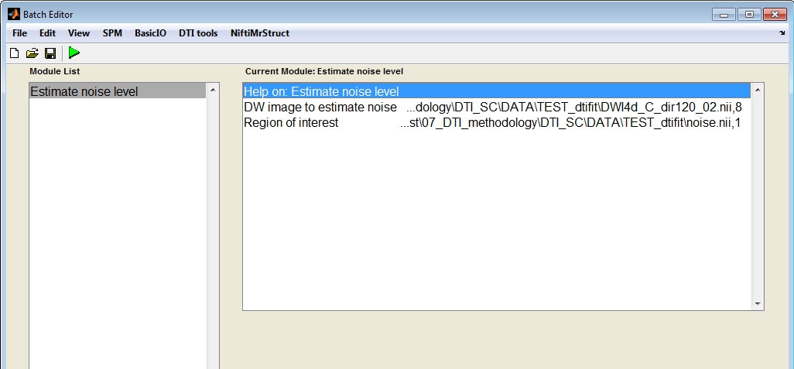

Running the batch will save a mat file (noise_estimate.mat) with the noise estimate inside. Use this value in the next step for robust fitting.

  - DTI fitting
In this step, the diffusion tensor is fitted to the pre-processed data. DTI fitting consists of multiple steps: (i) solving the diffusion signal equation (usually in the exponential form) to obtain the elements of the diffusion tensor), (ii) the eigenvectors and eigenvalues of the diffusion tensor are computed, and (iii) DTI scalar values are computed out of the eigenvalues.
SPM -> Tools -> ACID Toolbox -> Model fitting -> DTI
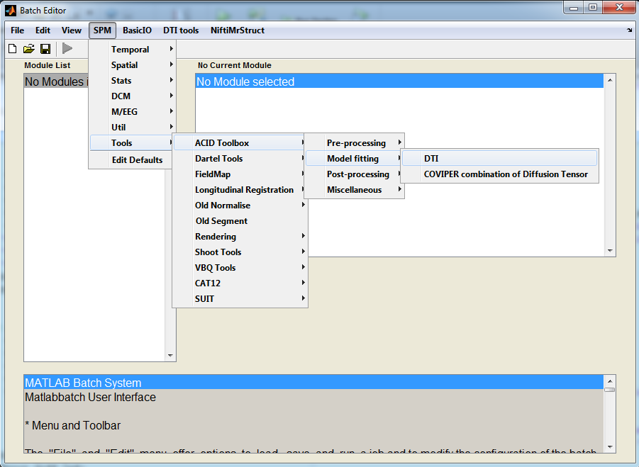
Following input has to be given:
DTI input images: select the fully pre-processed dMRI dataset here (rcDWI_*.nii).
b values (bval): enter the corresponding b values (see ‘Data quality check’ section on how to do this).
Diffusion directions (bvec): enter the corresponding diffusion directions (b vectors) (see ‘Data quality check’ section on how to do this).
Fitting algorithm: select the tensor fitting method. Recommended: Robust tensor fitting.
Region of interest image: if you use robust tensor fitting, it is highly recommend selecting a SC mask here. Restricting the tensor fitting to the SC will improve the computation of weights in the fitting procedure and will improve the performance of outlier rejection and robust fitting. For other fitting algorithms, specifying a mask will not affect the results (but will obviously restrict the fitting to the mask). You can create a SC mask either manually in MRICron or FSLeyes (see respective manuals regarding how to do it) or automatically using the sct_propseg algorithm in SCT (see ‘Normalization’ section). Importantly, the mask should nut cut into the spinal cord; a bigger mask is not a problem, but a smaller mask than the actual SC should be avoided.
Defaults general: it contains a few options that are mainly related to the output of the fitting. I suggest you use the default parameters.
Defaults for robust fitting: it contains parameters related to the robust tensor fitting algorithm. You should care about this section only if you have selected robust tensor fitting. I suggest you use the default parameters except for the ‘Noise estimate’, where you should enter the value obtained in the previous section (stored in the mat file ‘noise_estimate.mat’).
Defaults for DKI: it contains parameters for Diffusion Kurtosis Imaging, which is not the subject of this manual. Leave it as it is.
Defaults for brain mask: parameters related to brain DTI, not of interest in SC DTI. Leave it as it is.
