1. Time was registered in that way for each issue case

TMOB-288 : Don’t use Time Tracking – and Use TEMPO.

TMOB-290 : Use Time Tracking – and don’t use TEMPO.

TMOB-293 : Use Time Tracking – and Use TEMPO.

TEMPO REPORT, show 3.8 Total hours.

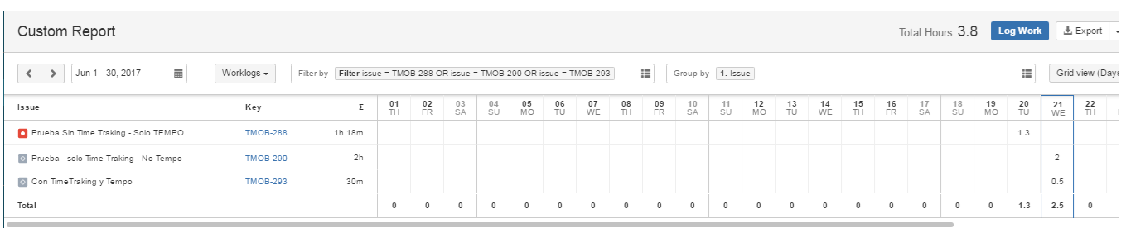

1. Using the same filter by the report TIME REPORT, only show the time of this issue:

TMOB-290 : Use Time Tracking – and don’t use TEMPO with Total time 2 hrs.

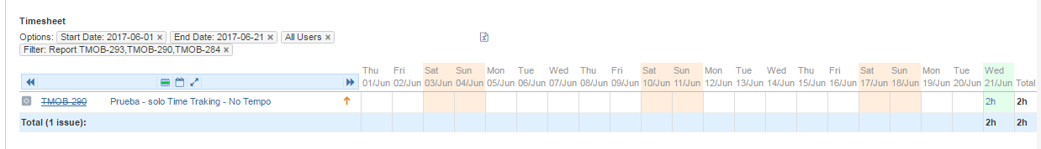

1. We make additional hours registration on “Time Spent”.

TMOB-293: Use Time Tracking – and Use TEMPO, we add 2.5 hours more for this issue.

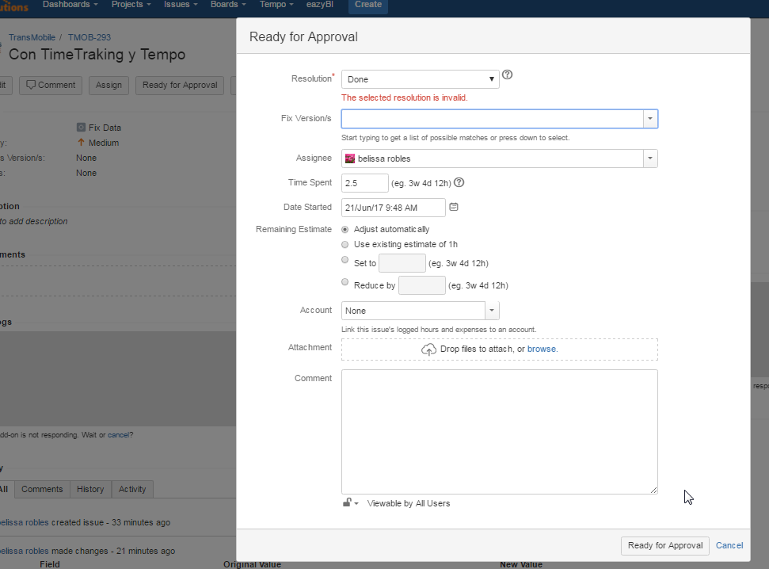

1. Backing to see both report, TEMPO and Time Report, we see the different.
   1. Tempo sum all the time ( tempo[worklog] + time spent)
   2. Time ticket only show the time of “Time spent”

The day 21/06/17 show 30 minutes different.

Total tempo: 5 hours.

Time report: 4.3 hours

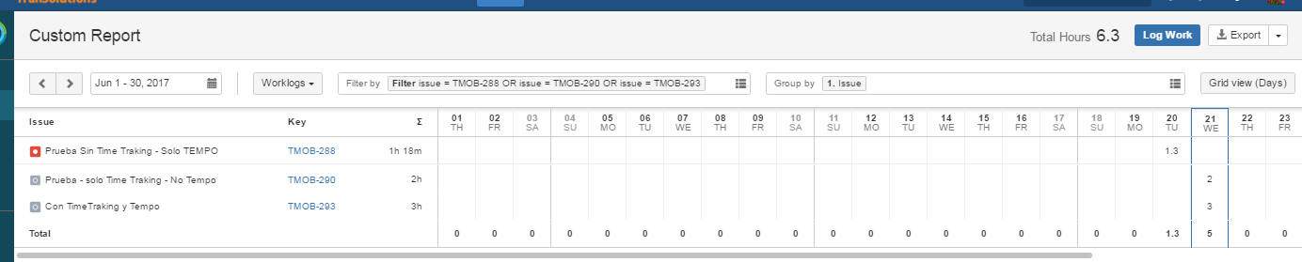

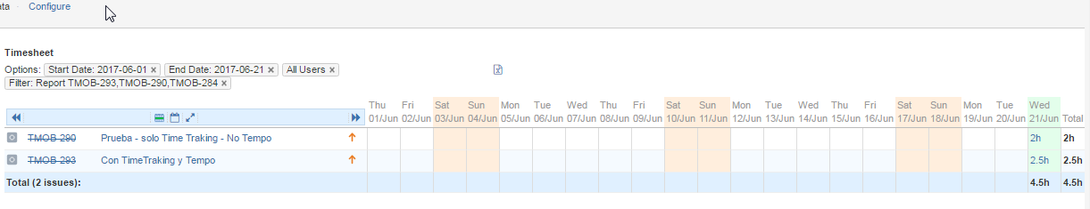

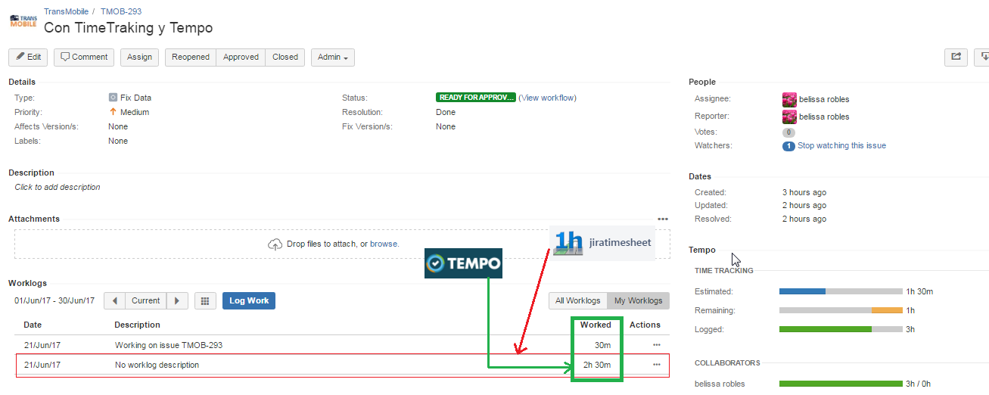

1. In conclusion your actual report is not working with the new version on tempo, because the people commented that before this tempo update in both reports show the same total time, and the people keep registrating in the same way .

Case 01: Don’t use Time Tracking – and Use TEMPO.

Case 02: Use Time Tracking – and don’t use TEMPO.

Case 03: Use Time Tracking – and Use TEMPO.

Could you please explain if your report work only with Time Tracking, or with Both and you will be upgraded the version on Time Report , because your report is very important for us.