Symptoms:

1. Could not show the project pivot report for a identified period of time for all projects
2. 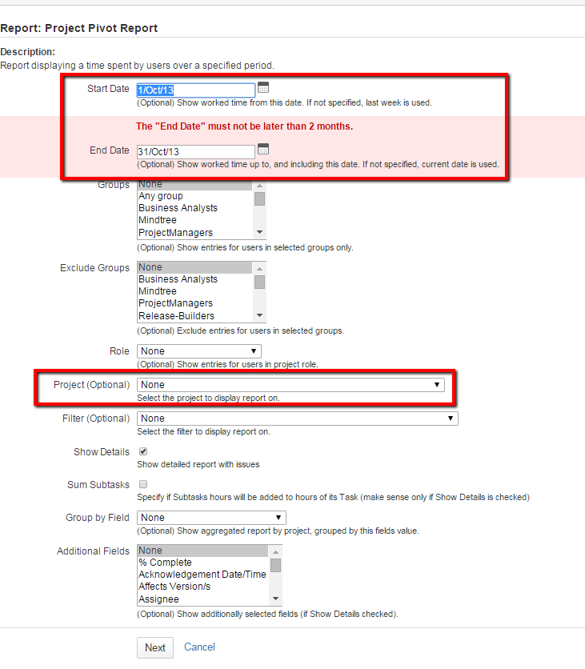
3. 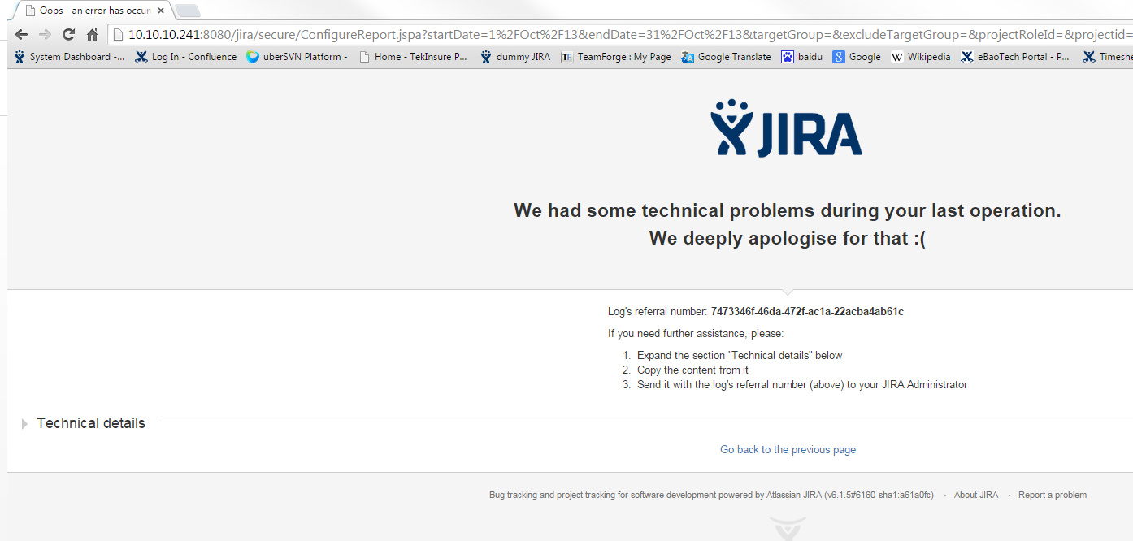
4. 
5. But when a particular project is selected within those period, it works
6. 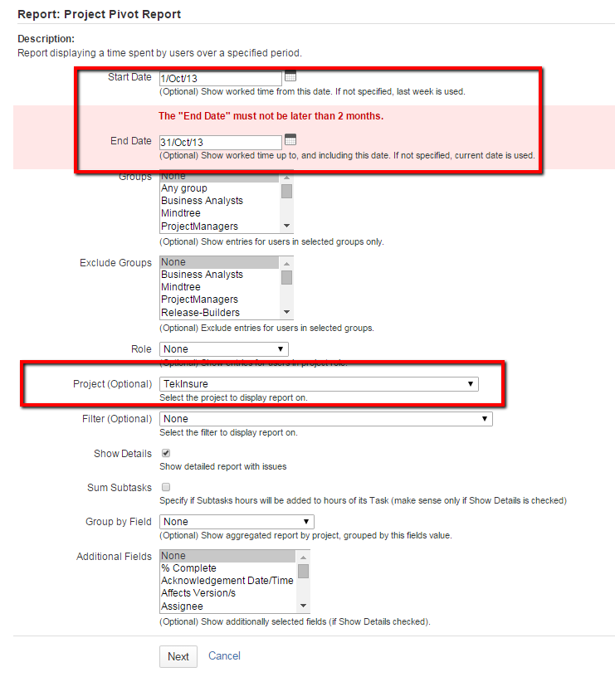
7. 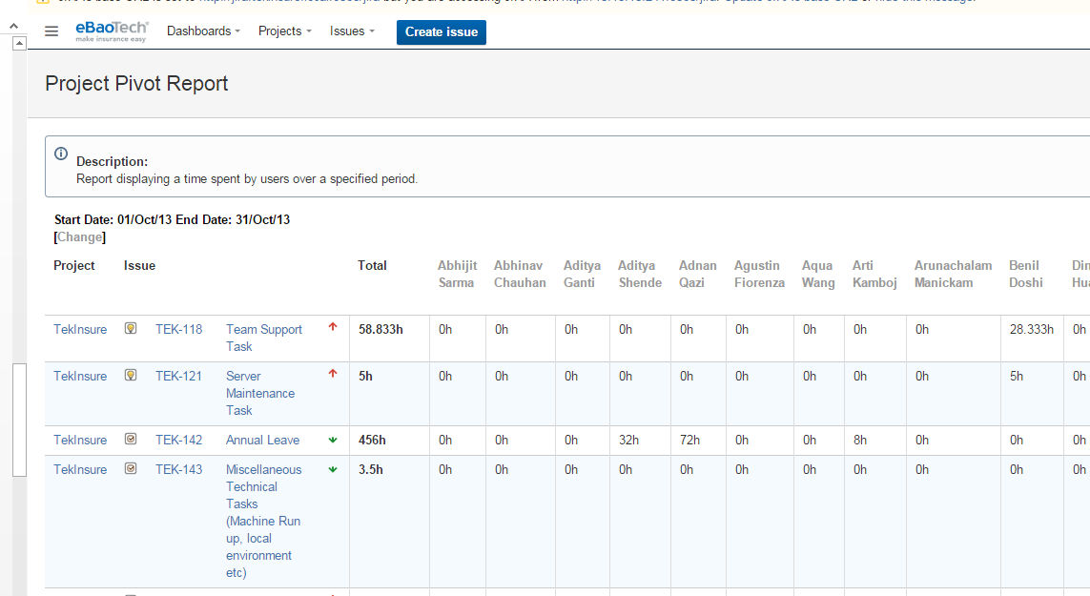
8. In addition, change it to another period of time and it work for all project as well
9. 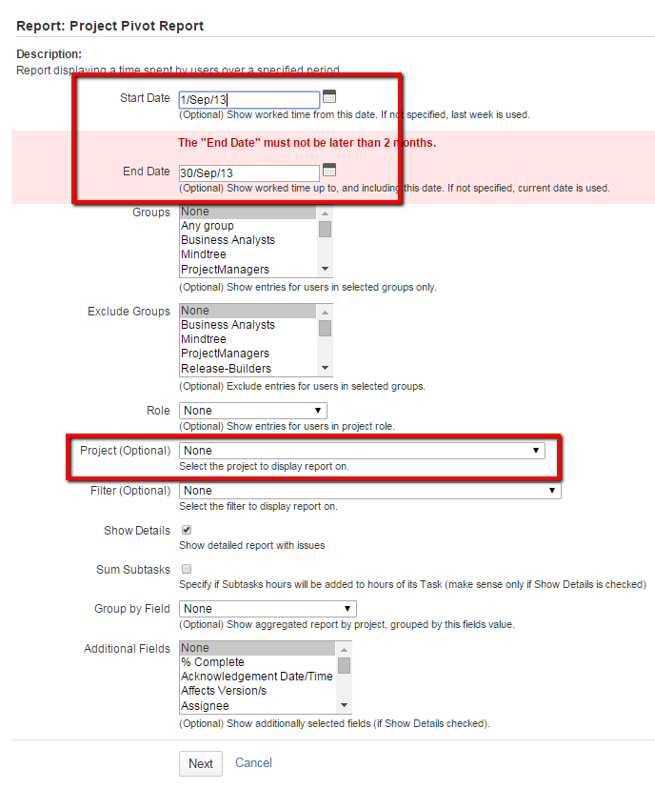
10. 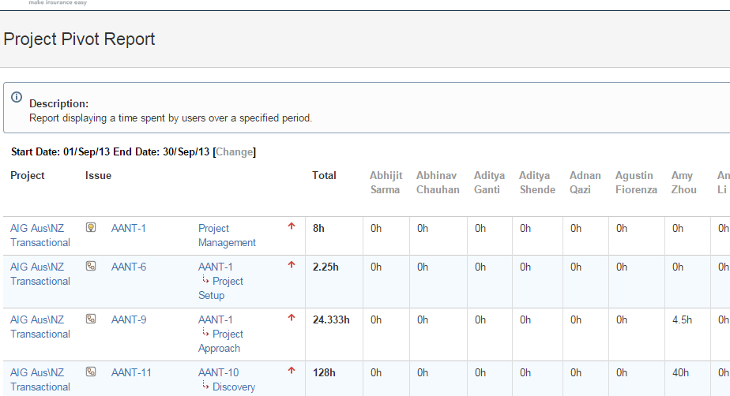

Solutions:

1. Request help from JIRA support
2. <https://support.atlassian.com/>
3. 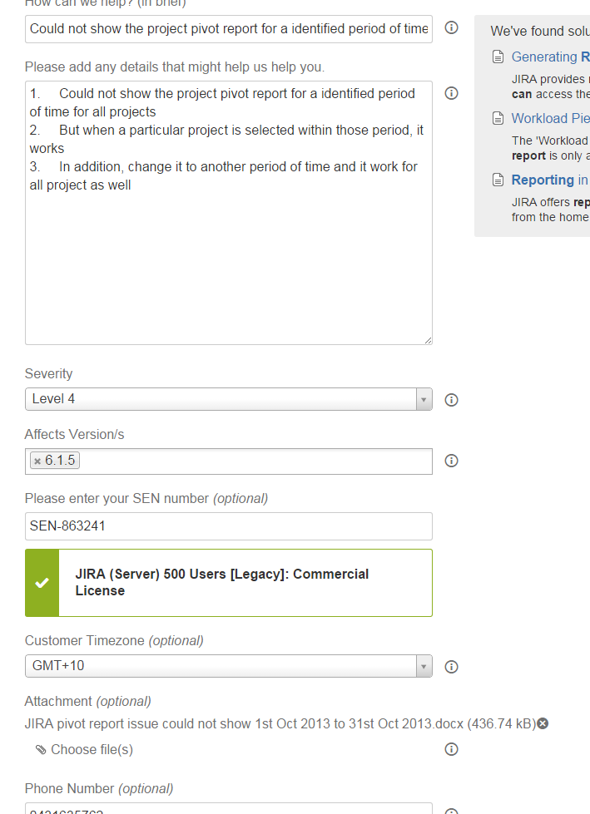
4. 