Allowing Comment Firstword as a Group by Field

# Thank you for the “Timesheet Reports and Gadgets Add-on”!

# We have installed it along with Work Calendar and believe we have setup a good system for time sheet capture and management.

# The one thing that would make it perfect for us would to be able to have a *Group by Field* thatis the first word of the Comment.

# What we would like to do is - record in the first word of the work log  - work description/comment field a skill then use the rest of the line as description.

# For example:

# cid:image002.jpg@01D1029C.756DD120

# We would like to use the first word of the Work Description/Comment to describe the skill be used eg. test, analysis, design, build, etc then have the rest of the line for free form comment.

# e.g. test – Testing the new system with staff users

# If we could then if you could provide field like  *Comment Firstword* to use in *Group by Field* we could produce the following sort of Pie charts with your Timesheet gadget  - where we could report by the skill.

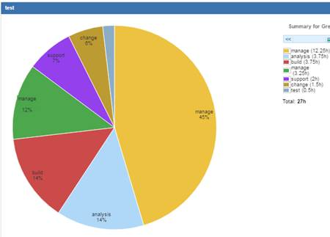

I’d really appreciate it if you could consider this request – that hopefully might be simple, but would provide enormous benefit for us.

Cheers

Greg