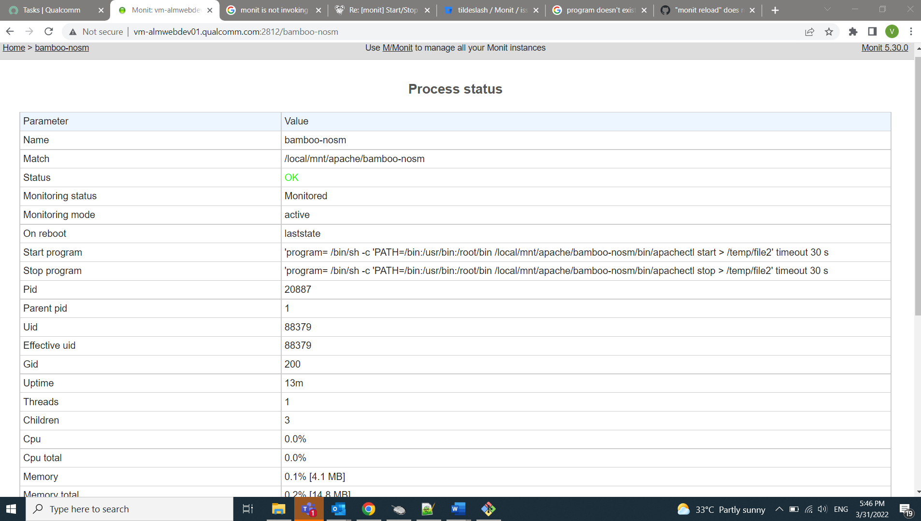

Monit is erroring out to start the execution:

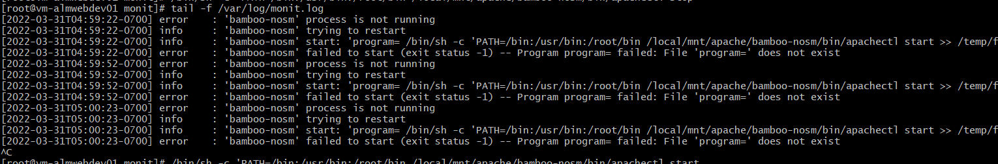
Monit reload giving verbose as follows even though script exists;

